Code structure

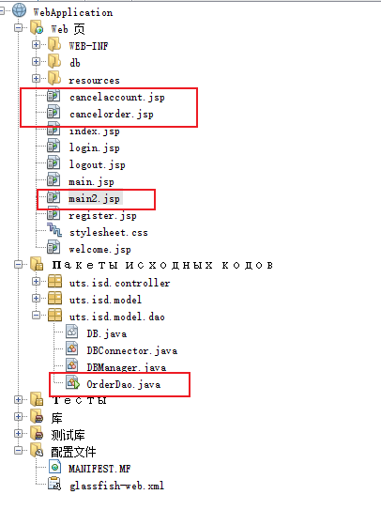

Since the logic of login authentication is not implemented, login.jsp cannot get the information of the logged-in user after jumping to main.jsp. Main2.jsp makes a logical judgment and specifies a fixed test account: userid = 103

After u developing the main.jsp authentication, we can use your authentication.

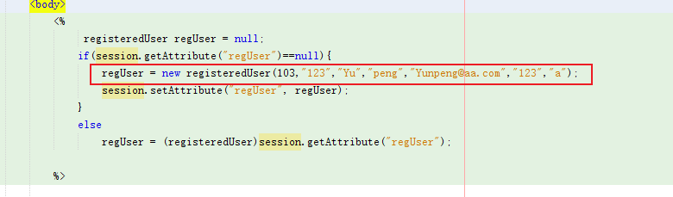

# Function:

1. If a user cancels an order, then the order status is set to “cancelled”. - DONE ASSIGNED MEMBER - Yupeng

2. If a user cancels their user account, all saved orders made by this user should be

automatically cancelled - DONE ASSIGNED MEMBER - Yupeng

# Implementation：

1. Jump to main2.jsp

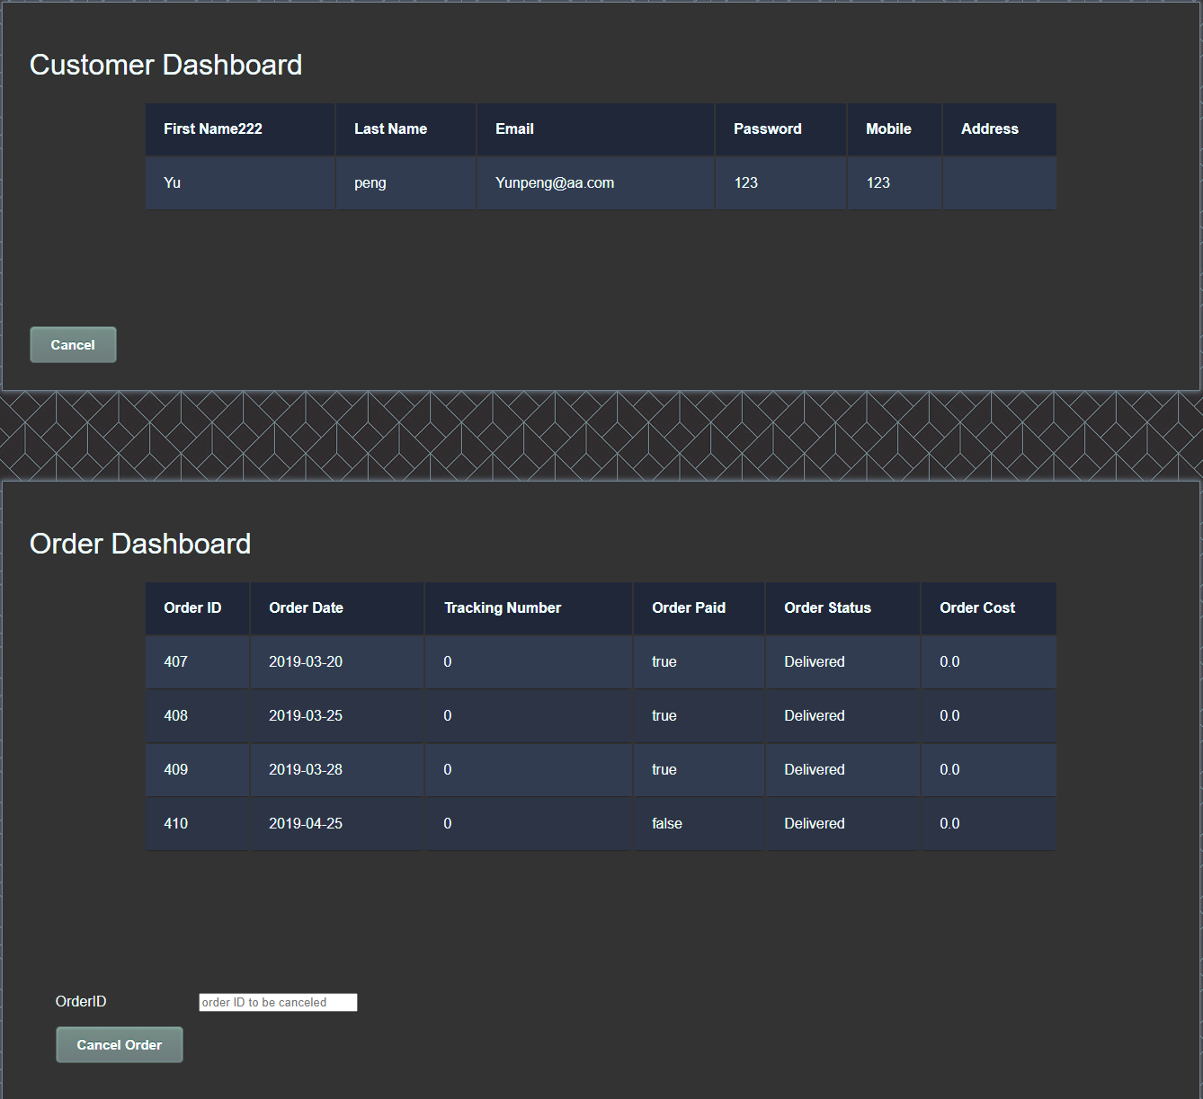

1. Cancel Order
   1. If the order id is empty, click cancel Order button（Click back can return to main2.jsp）

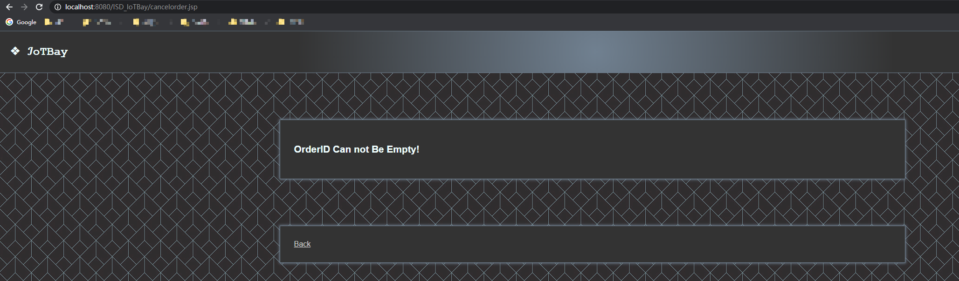

* 1. If no exists of order id , click cancel Order, the page will elert: “Order not exists”

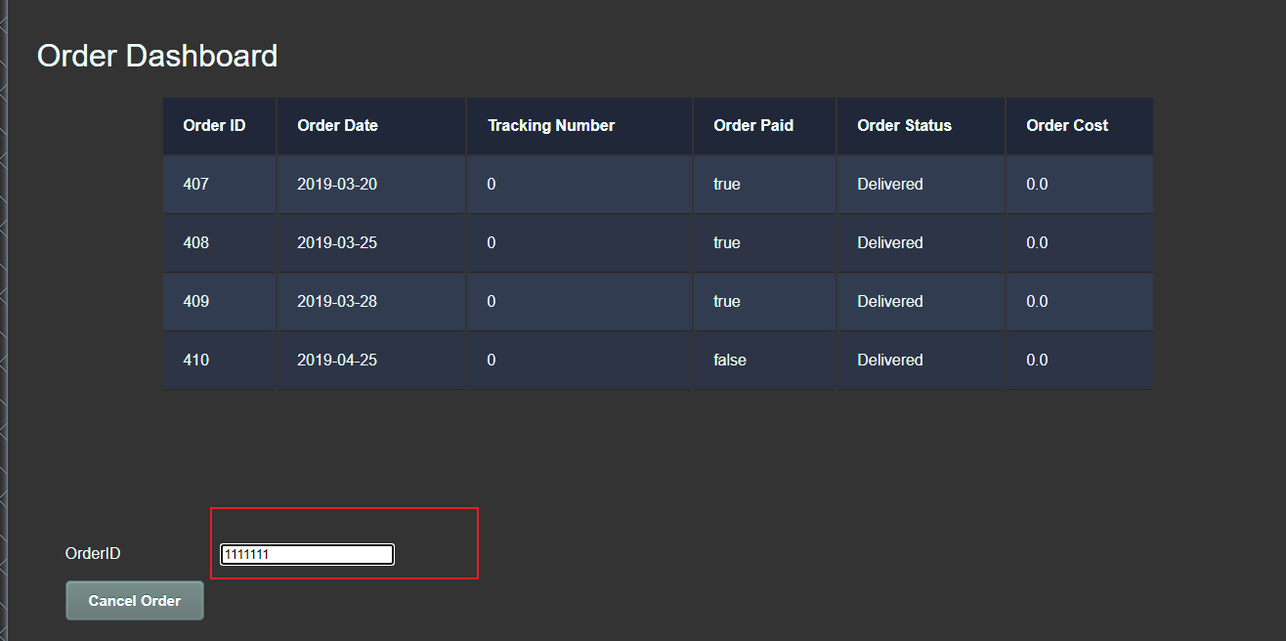

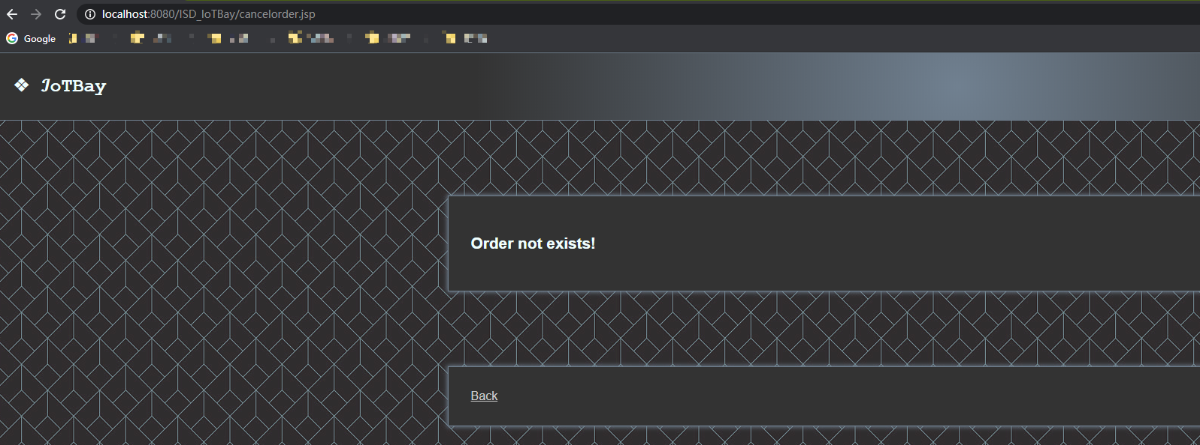

* 1. Enter the non-self order, click the cancel Order button. The page will alert ”Cannot cancel other orders”

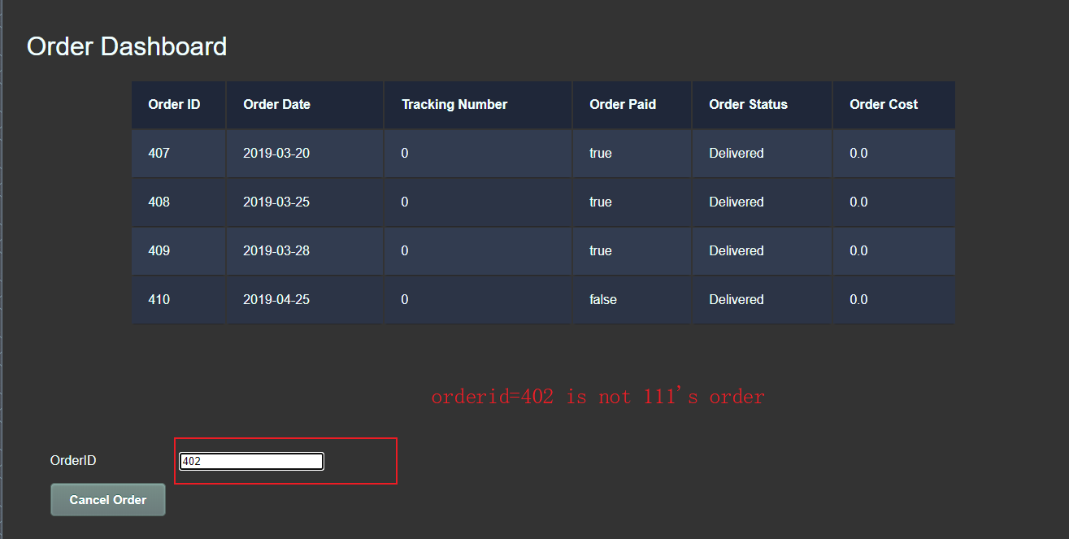

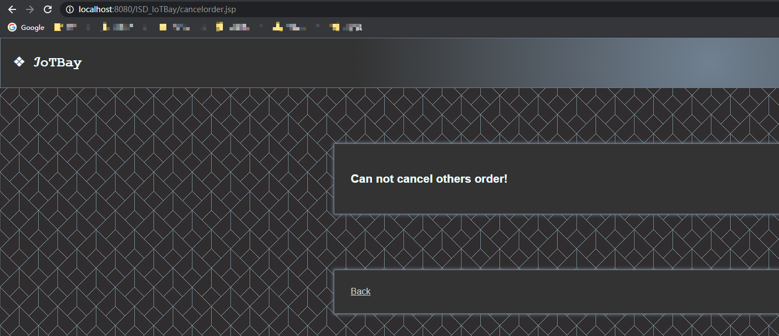

* 1. Enter the correct order number and click the cancel Order button

The page shows ”Cancel Success”

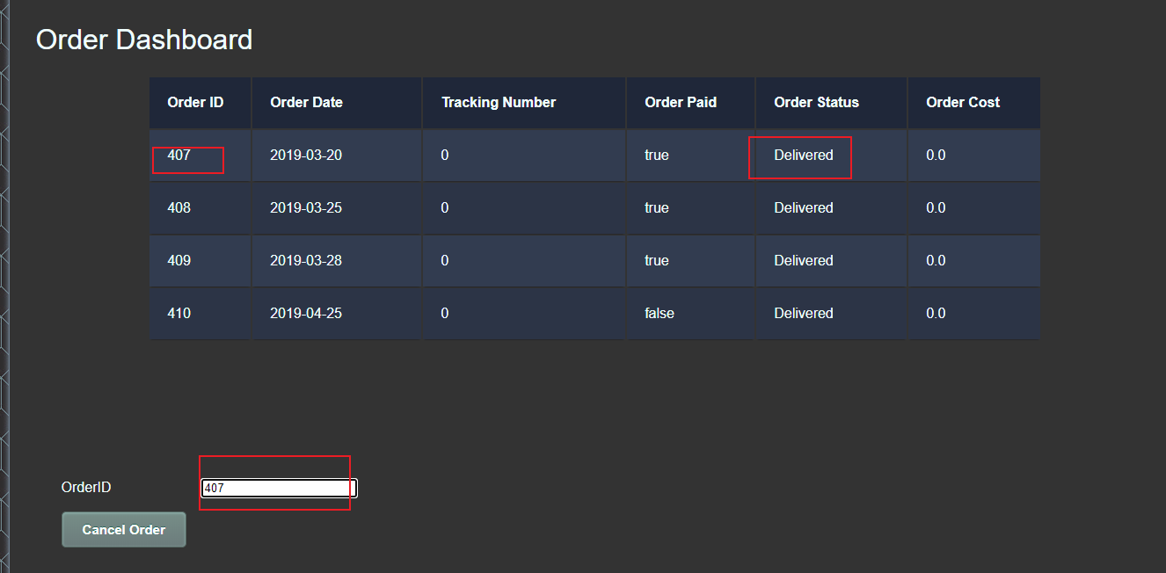

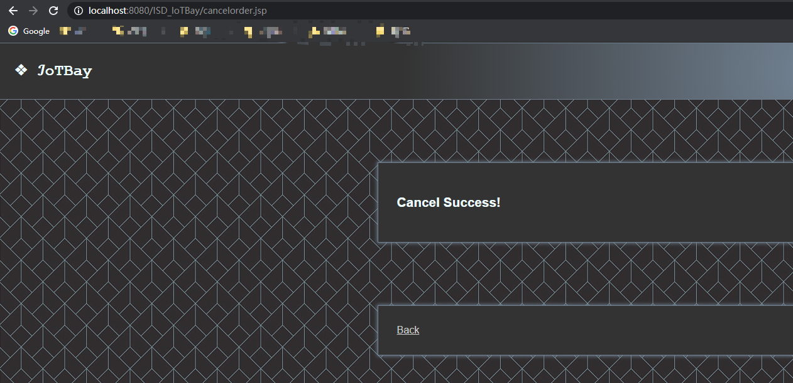

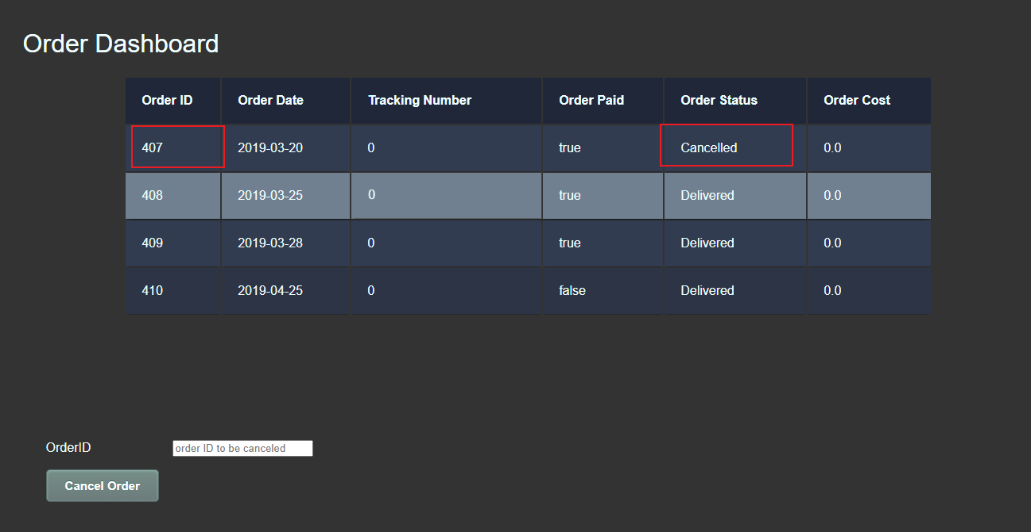

1. Close the personal account, the status of all orders under the account will become cancelled

